**WHAT IS DATA?**

It is a thing that helps to make decision for a domain, data itself is not a technical thing, But to analyze the data technical skills are used.

**TWO TYPE OF DATA**

1. Physical data – which is in phone, ac remote

**DATA SCIENCE**

We working on data with science like the mathematical functions. A data scientist will build custom algorithm.

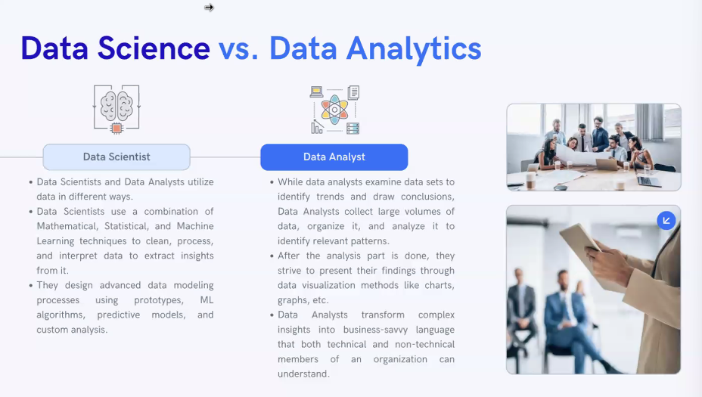

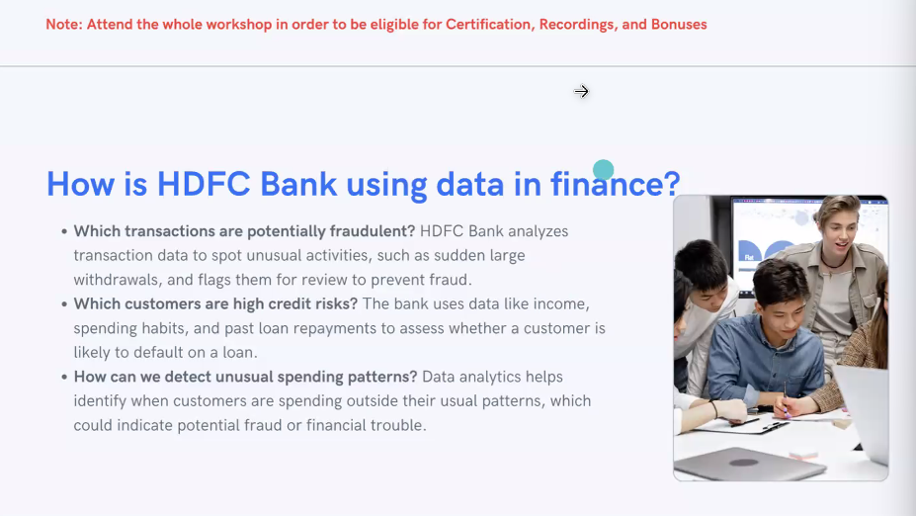

There will be two type of models can be developed to process and make prediction on data. That are custom model with python (pytorch), pretrained model

**MAIN SKILSS FO DA**

1. Excel
2. Power Bi
3. SQL
4. python
5. Problem solving